Module Assembly

Untitled Space Craft modules follow a consistent manufacturing design language, the process of which can be separated into three parts: Faceplate fabrication, component placement, and PCB soldering.

Faceplate Fabrication

These instructions are for if you are using acrylic for the faceplates. If you are using another material, then you will have to modify these instructions to fit your use case.

Faceplates should be laser cut from 5mm acrylic. A suitably powerful laser should be used to prevent the resulting cuts from becoming a pyramid shape. The faster the cut the less the surrounding material gets burned by an unfocused laser.

Inking the faceplates involves liberally applying ink to the etched lines so that the ink fills all the gaps. It is recommended to clean the burnt acrylic dust out of the gaps first.
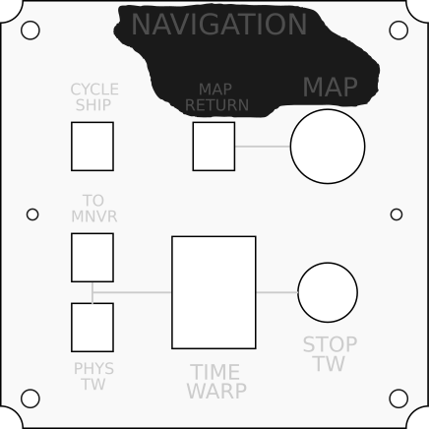

Any solvent-based ink can be used, such as alcohol-based or acetone-based, typically used in dry-erase markers or permanent markers. Inking can be performed with or without the paper covering. After applying the ink, wipe the excess off with a tissue and wait for the rest to dry. Once it has dried, you can remove any remaining excess using the same solvent as your ink.

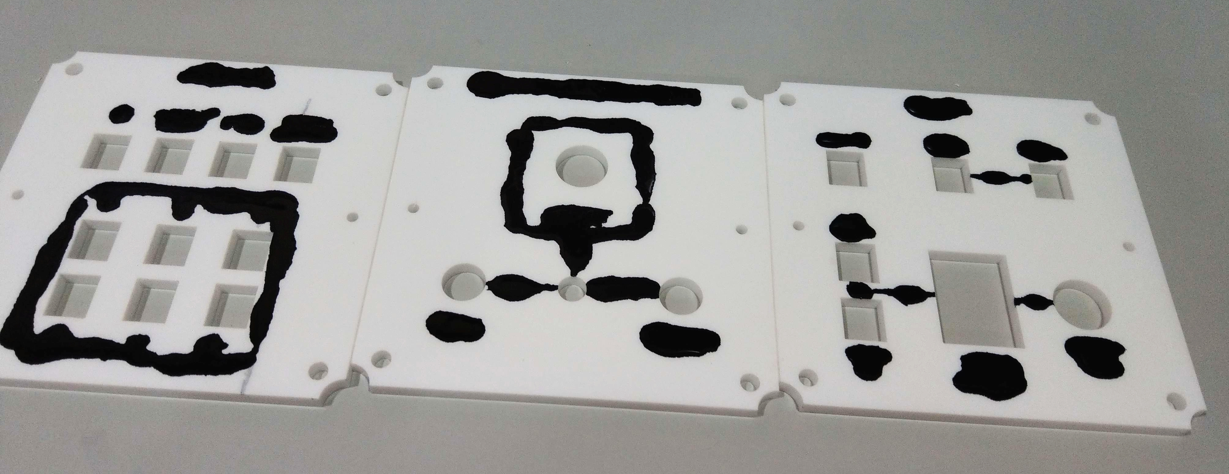

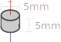

Magnets can be added to the acrylic by pressing them in with a vise or similar compression tool. Magnets should be inserted with the NORTH side UP and pushed in from the top side to ensure the side that contacts the container is flush. Each magnet is 5mm in diameter and 5mm thick.

Component Placement

Most modules use just a handful of components, with a few specialty parts that are module- or function-specific.

Common buttons include the Square Button, Circle Button, LED Button, and the JH-D400X Joystick. In general, components have an orientation in which they should be inserted into the acrylic, which depends both on the function of the component as well as its pin/wire placement. These orientations are best determined by checking the PCBs which have dotted lines indicating where wires should connect, which should be matched by the location of the pins on the component.

Square Buttons are about 14mm square on the surface, but underneath they are 11.85mm by 11mm. They fit into a hole 13mm x 11.2mm, with the extra space being taken up by the wings on either side. These wings compress to provide a stronger friction fit. However, they will typically only compress on one side, so it is worth making sure that compression happens on the same side uniform across your controller. The bottom side is preferred so the hole is better covered towards the user.
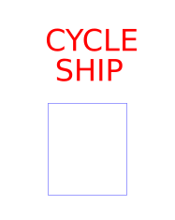
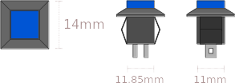

Circle Buttons are 15mm in diameter on the top and 11.5mm in diamater on the bottom. They fit into a hole 12mm in diameter.

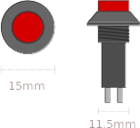
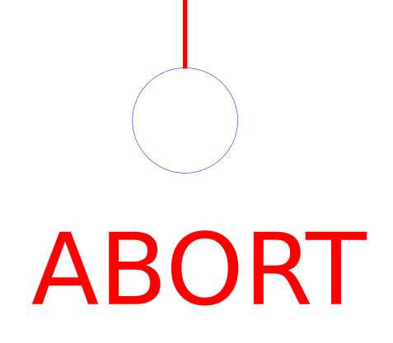

LED Buttons are 18mm in diameter on top and 15mm in diameter on the bottom. They have two sets of pins, one for the button and one for the LED. The pins for the LED are designated with + and – which should line up with the + and – on the PCB.

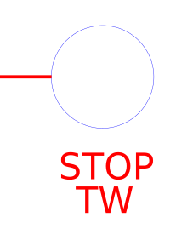
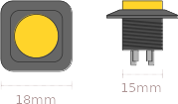

LED Switches are harder to source, but the ones used in production builds fit into a hole 20mm in diameter and have a similar 4-pin layout as the LED Buttons.

Switches come in a few varieties but they all share the same basic body plan, 13.2mm by 8mm at the base, with a threaded spire that is 5.9mm in diameter. They fit into a hole that is 6mm in diameter.
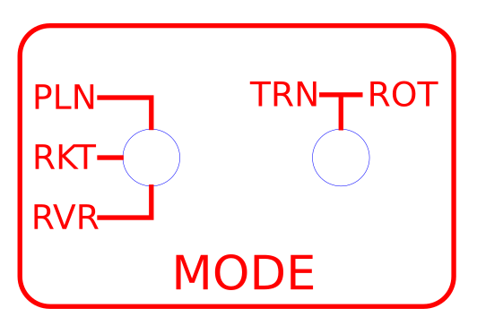
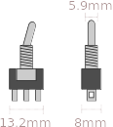

The JH-D400X Joystick is a complex part with 3 potentiometers and a pushbutton. Its dimensions are well-documented.
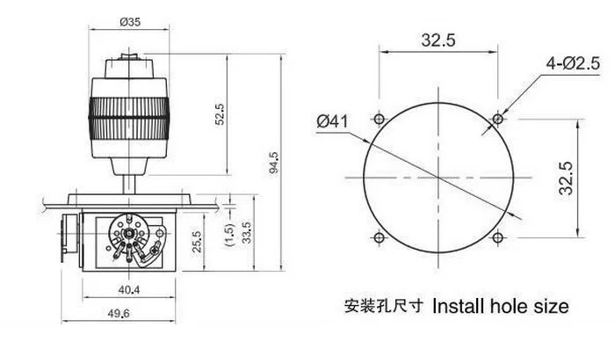

It has a rubber gasket that should go on top of the acrylic, with a ring to secure it. It’s orientation can be determined by the shape of the hole in the PCBs. These joysticks often arrive from the manufacturer with poor calibration, so it is recommended to test the resistance of the stick at rest and its min/max in each axis before soldering.

The Throttle Lever is an STL file included in the USC repository. It includes a friction mechanism that snaps onto the bottom of the PCB. Both parts require more consideration than other components and will be covered in a later section. Their assembly occurs during or after soldering.



PCB Soldering

The PCBs for each module are filled with documentation which should be carefully read and considered before working. Every PCB in the project is single-sided, with the components and wires both being mounted on the side with documentation.

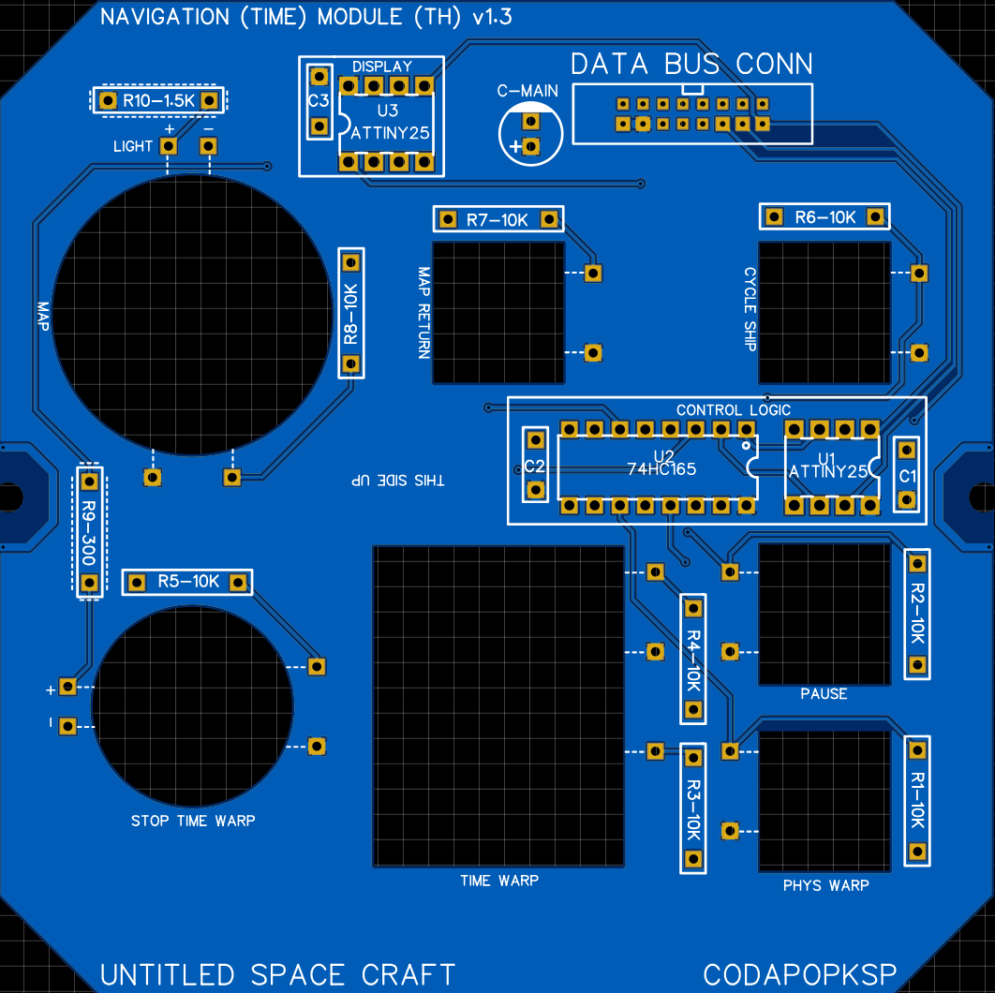

There are many resistors on each board, and over half of them are 10k Ohms. Resistors that aren’t 10k Ohms are denoted with a dotted border. Some holes, particularly those near buttons or switches, have dotted lines pointing toward a component. These are to indicate the component they are a part of as well as where the component’s pins should be for it to be in the proper orientation. The wire should go from its hole to the pin nearest to the dotted line.
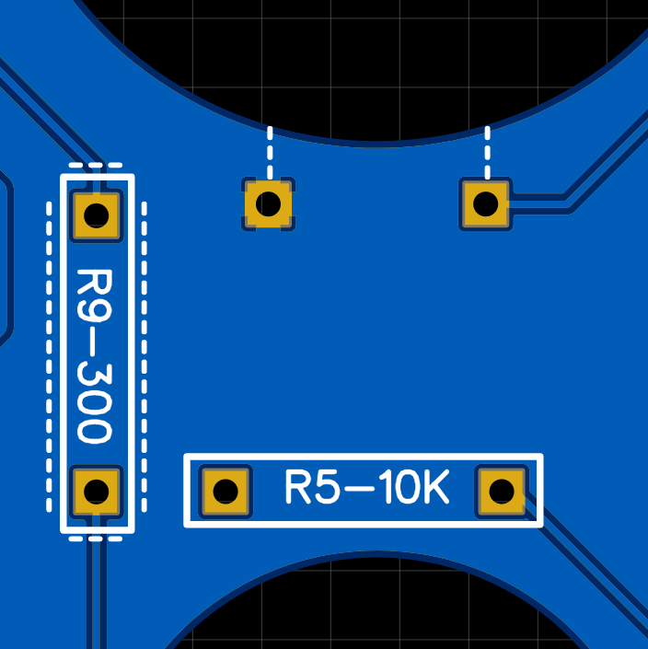

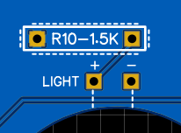

Some holes are marked with a + or – symbol. These are used for LEDs or electrolytic capacitors that have a strict polarity. Some components also have + and – symbols on them. These should match the symbols on the PCB (+ to +). LEDs and electrolytic capacitors. have longer or shorter legs to indicate + or – respectively.
Typically all PCB components such as resistors, capacitors, and chip sockets should be soldered and cleaned first, with the user interface components like buttons, switches, and LEDs added later.

The wires need to be cut and added to the PCB before they are connected to the user interface components. One way is to use a helping hands device to hold both the PCB and a wire and to solder it in through the bottom.
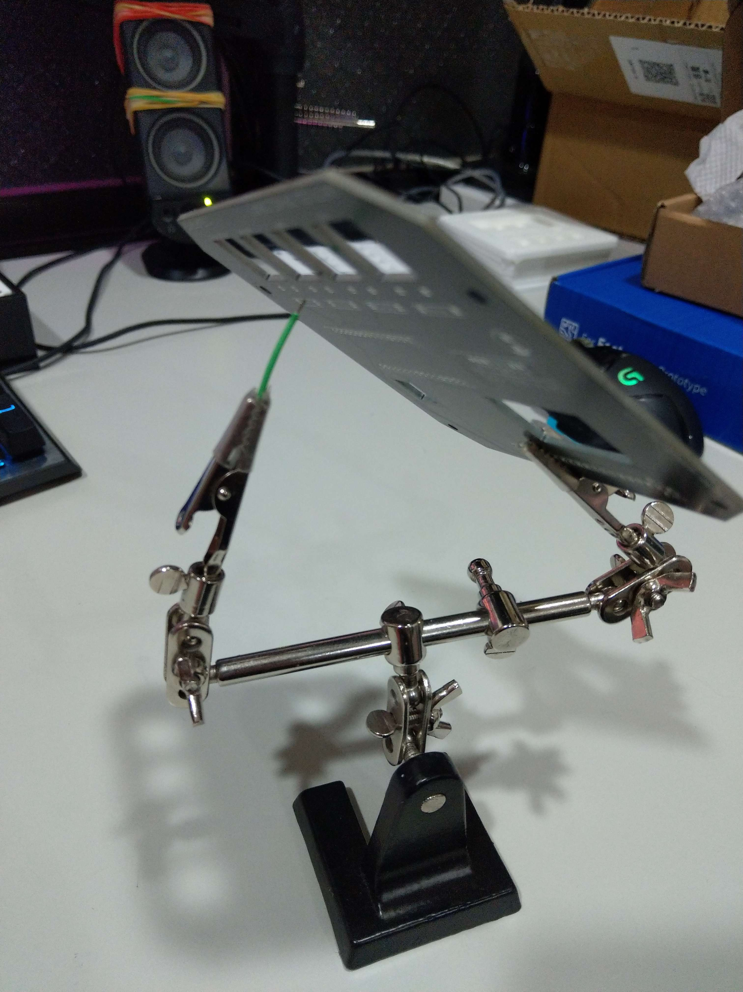
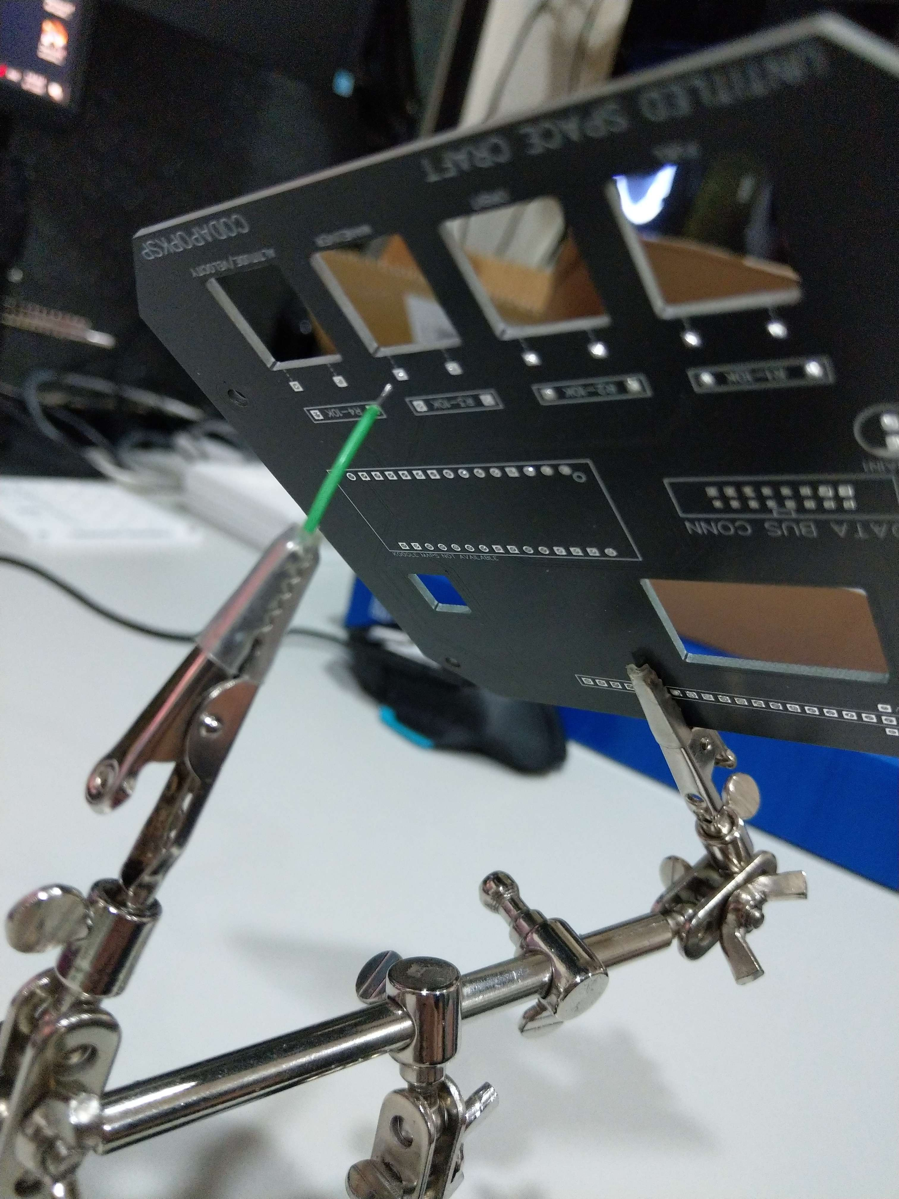

For LEDs to connect to the PCB, they often need to be bent in a U shape so their legs curve into the holes. Be sure not to let the legs touch each other. Below is an example.

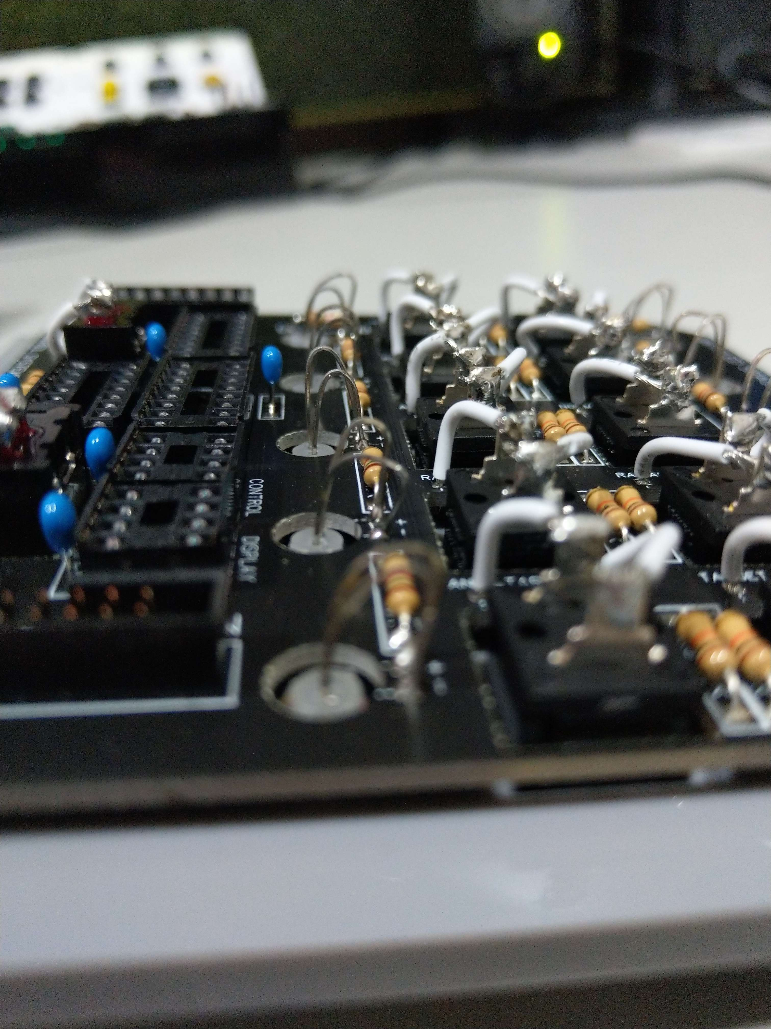
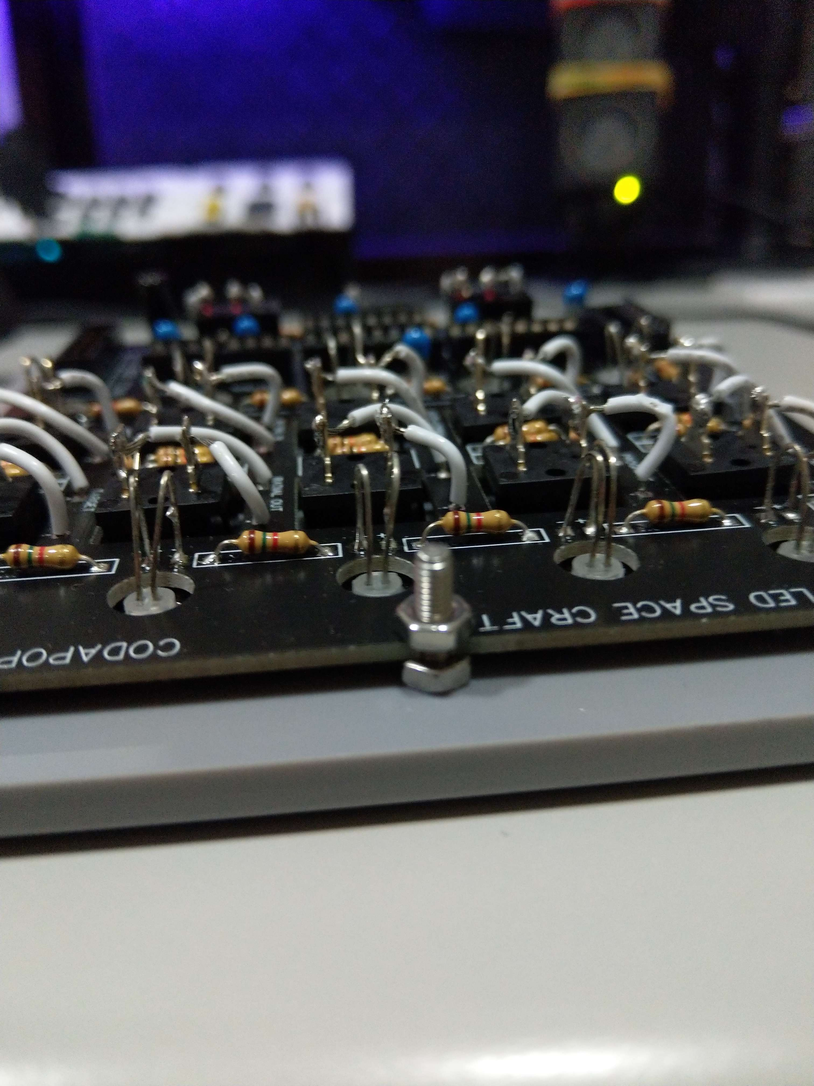

This is the typical flow for most modules. Special cases will be discussed below.
Throttle Module

Soldering the Throttle Module is more complex than most other modules and requires a very careful review of the sequence. At each point, think about how you are going to do the next several steps to ensure your plan makes sense.

Since the throttle lever needs to stick onto the end of the potentiometer, and the lever needs to fit through the holes of both the PCB and the acrylic, then this potentiometer cannot be soldered until later. Typically the sequence goes:

1. Solder all regular PCB components.
2. Solder all wires onto the PCB.
3. Stick all the buttons and switch onto the acrylic.
4. Feed the lever through the acrylic and PCB.
5. Fasten the lever onto the potentiometer.
6. Solder the potentiometer to the PCB.
7. Secure the PCB to the acrylic and solder the remaining wires to the components.

Extra care must also be taken to ensure the notch in the potentiometer is perpendicular to the shaft of the lever. This should be matched as closely as possible, though minor errors will be handled via calibration.

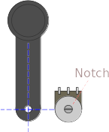

If printing with the unmodified STL files in the repository, the side facing the print bed should be the side that faces the potentiometer. This is because the opposite side is recessed a bit in order to fit the Throttle Guard.

The Throttle Guard is the name of the friction device that keeps the lever stationary when not actively being moved by the user. It fits into holes in the PCB and touches the lever underneath the module.
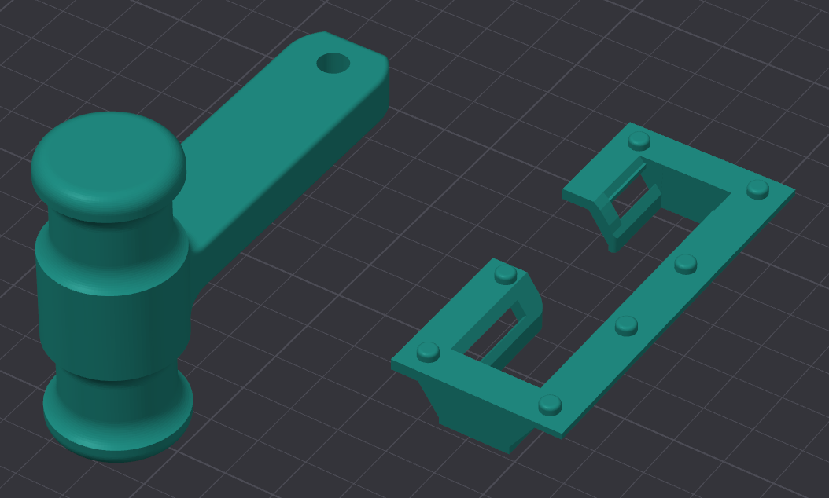

It is recommended to print several Throttle Guards and to treat each of them with different thickness of some other material wound around the contact bar (such as a thick tape like gaff tape). The number of winds of tape will alter the friction and compression of the lever. Too little, and the lever may move under gravity or inertia; too much and the Throttle Guard may plastically deform over time.

Once the fit is determined, the Throttle Guard should fit firmly into the PCB, but super glue can be used for added strength.
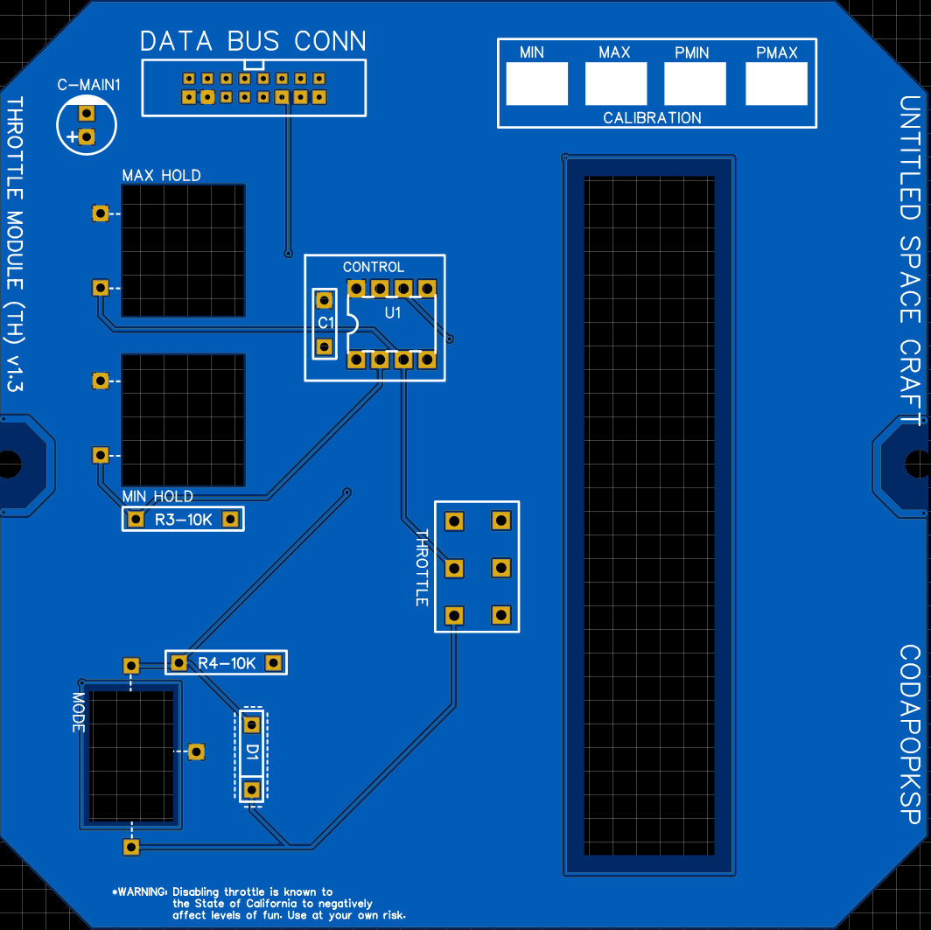

Calibration involves running the Throttle test script and reading the values in the Arduino Serial Monitor. First check the values of the throttle lever all the way down and all the way up, with the Mode switch in the ENBL (Enable) position. These values are the MIN and MAX. Then do the same with the Mode switch in PCSN (Precision). These are PMIN and PMAX.

It is recommended to write these values on the PCB in the designated areas. Then these calues can be patched into the Settings.h file in the firmware prior to upload.
Telemetry Module

The Telemetry Module is the only module that uses an Arduino Nano rather than an ATTiny chip. This Arduino should be soldered directly to the PCB with the USB port aiming away from the center towards the edge.

The screen itself needs to be carefully added, with washers and nuts used for spacing. The sequence goes:

1. Solder all regular PCB components.
2. Solder all wires onto the PCB.
3. Stick all the buttons onto the acrylic.
4. Feed the 4 long 3M screws through the PCB.
5. Add two thin 3M washers and a 3M nut to each screw for spacing.
6. Add the screen onto the screws.
7. Use two more 3M nuts onto each screw.
8. Push the PCB onto the screws and all the way down onto the pins for the screen.
9. Add the final nut to each screw and secure it tightly.
8. Solder the screen pins and button wires.

The final sequence should go:

[Nut] [PCB] [Nut] [Nut] [Screen PCB] [Nut] [Washer] [Washer] [Acrylic] [Screw Head]

If your washers are thicker, then you may only need one.

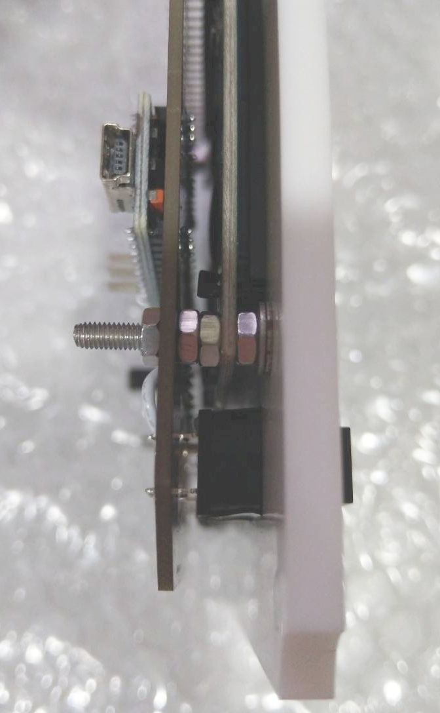

Joysticks

Each joystick has 6 pins sticking out the sides (from the potentiometers) and should be fairly straightforward to wire up, as they just connect to the PCB with jumpers from Axis 1 and Axis 2.

There are also 5 wires sticking out the side of the joystick: red, black, white, and two yellow. These go in the remaining empty holes next to the joystick labeled "Button" and "Axis 3". These holes are also labeled with letters that match the name of the color of the correct wire. R for red, B for black, and so on. I typically do this step after soldering the other wires to the PCB but before securing the PCB to the acrylic.

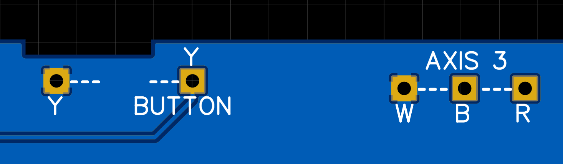

EVA Module

The EVA module is, for the most part, the same as the standard modules. The only difference is the 10 LED array for displaying EVA propellant. This array is organized with all of the anodes of the LEDs on one side (the side with the serial number sticker) and the cathodes on the other.

The array should be soldered to the PCB after the PCB and acrylic have already been joined, and it is nearly the final step of building the module. Soldering it first might prevent it from fitting into the hole in the acrylic later. The resulting array should stick up out of the acrylic slightly.

Adding the IC Chips

The ICs come in four different varieties. 74HC165, 74HC595, ATtinyX5, and ATtinyX4. It is recommended to use sockets for all your ICs to greatly reduce the time cost of fixing a module in event of a failure

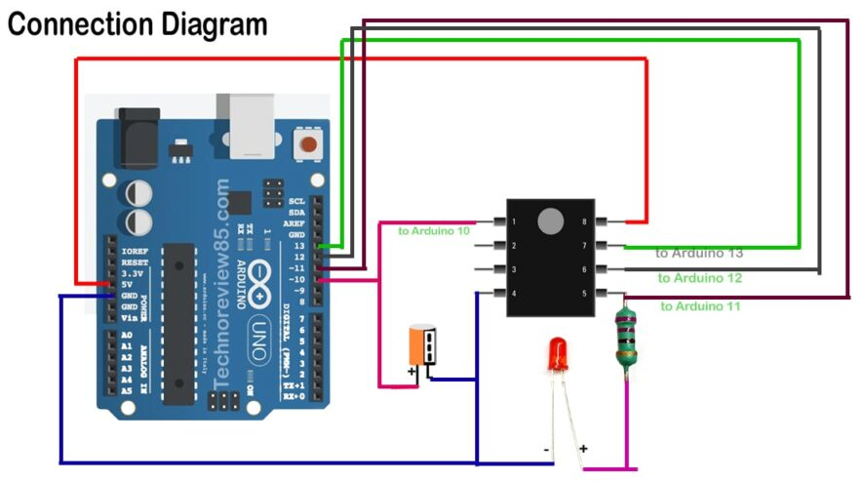
The ATtinyX5 and ATtinyX4 chips are microcontrollers and need to be programmed. You can do this on a breadboard with directions for a simple ISP programmer circuit with this guide.

